Task No & Title: | Integrate Commercial computer packages
Title: | 11_04 Take the Office Quiz
Suitable for Classes: | Certificate II Business
Area: | Technology & Enterprise
Teacher: | Mr Peter Faulks
Timeline | 1 Lesson
Date Due: | Today

Task Brief:

Files Required

Items highlighted in yellow are tasks for you to complete
Items in Purple are help tips
11

Unit | Number | Title | Study Time
1 | BSBCMN201A | Work effectively in a business environment | 20
2 | BSBCMN202A | Organize and complete daily work activities | 15
3 | BSBCMN203A | Communicate in the workplace | 30  
4 | BSBCMN204A | Work effectively with others | 20
5 | BSBCMN205A | Use business technology | 30
6 | BSBCMN211A | Participate in workplace safety procedures | 15
7 | BSBCMN213A | Produce simple word processed documents | 40
8 | BSBCMN214A | Create and use simple spreadsheets | 20
9 | BSBCMN108A | Develop keyboard skills | 40
10 | BSBCMN107A | Operate a Personal Computer | 20
11 | ICAITU013C | Integrate Commercial computer packages | 30
12 | ICAITU012C | Design Organizational Documents using computer | 50
 |  | TOTAL

11_04 Take the Office Quiz –

see how much you really know?

Quiz starts next page

GENERAL KNOWLEDGE

- Type your name in Arial 16 Bold

(1 mark)
Answer:

- List three ways you can demonstrate good ergonomic practices in a classroom? (3 marks)
Answer:

- Name three software applications you have used this year.
Describe at least one situation for each of the applications.

(6 marks)
Answer:

- Explain the technology process in your own words.

(4 marks)
Answer:

WORD PROCESSING

- Explain the steps involved in changing the page margins?
Answer:

(2 marks)

- Write your name in the space below and format it as follows:
Word Art Arial Black 18pt (1 mark)
Answer:

- When typing a letter how many returns are left between the date and inside address? (1 mark)
Answer:

- Where would I go to change the line spacing of a paragraph?
Answer:

(1 mark)

- What does it mean if a letter is fully justified? (2 marks)
Answer:

- A letter has open punctuation when…? (2 marks)
Answer:

- Why is it important to print preview your work before printing.
Answer:
(1 mark

- Using the table below do the following: (6 marks)

- split row 4 into 8 columns

- shade rows 1 and row 4 grey

- put a double line border between rows 1 and 2

- head each column with the name of a month eg January, March

- increase the size of each column heading to 16

- add a colour to the top row

Answer:

- What is the quickest way of moving between the cells of a
table? (1 mark)
Answer:

- What tab alignment is usually used for numbers?

(1 mark)
Answer:

- What is the default setting for tabs? (1 mark)

Answer:

POWERPOINT

- When choosing a slide layout how many choices do you
have? (1 mark)

- 8

- 10

- 12

- Write the names of three slide layout choices that you used
in your presentation? (3 marks)

- Under which menu do you change the slide background?
(1 mark)
Answer:

- How many different ways can you view your presentation?
(1 mark)

- 2

- 4

- 5

POWERPOINT

- What is the name of the following slide view? (1 mark)

Answer:
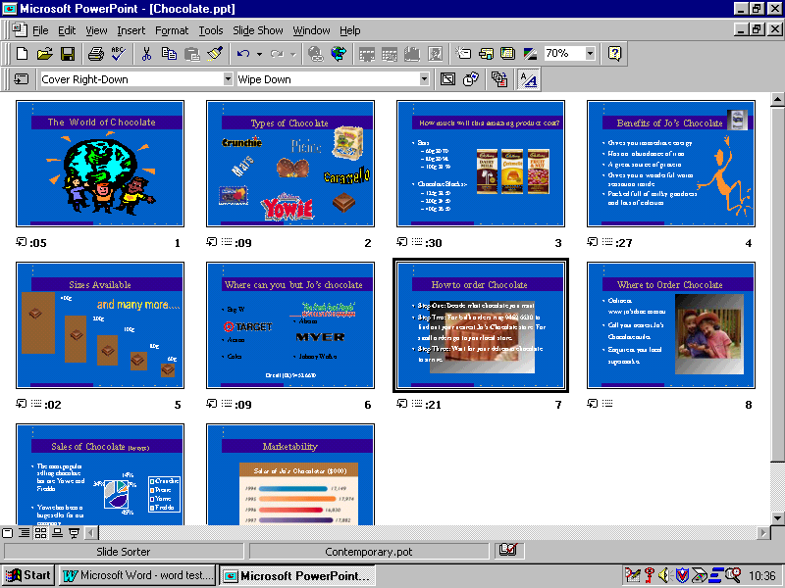
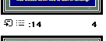

- Follow the arrow. What do these three symbols stand for?

(3 marks)

- Why would you include timings in your PowerPoint
presentation? (1 mark)

Answer:

Desktop Publishing

- On the three-fold brochure design, specify where you would
type the following: (6 marks)

- Front cover
- Back cover
- Inside flap
- Inside information 1
- Inside information 2
- Inside information 3

Answer:

Page 1

Answer:

Page 2

Student Name: | Date submitted:
I declare this evidence to have been produced by me the undersigned.

Candidate’s signature:
Title of Portfolio evidence presented (include Unit No and section i.e. 03.05)
:-
□ Outcomes from learning programs (including self-learning and online learning)
□ Assessment feedback (from a trainer or assessor)
□ Observation checklists (from a workplace supervisor or assessor)
□ Written statements or references (including workplace supervisors, community leaders)
□ Job descriptions
□ Work journal
□ Work samples
□ Finished products
□ Product descriptions or specifications (supporting the product samples included)
□ Statutory declarations
□ List others (or delete any from above not provided)
- All work submitted to be word processed and spell checked.
- There must be at least two samples of evidence for each
Element within the Unit of Competency. This is sample 1 / 2
- All work submitted must be of a high quality and meet the
requirements of the Unit of Competency.
Other evidence (List each piece):
Assessor to complete
Evidence is Valid Sufficient Authentic Current
□ □ □ □

Assessor signature: _________________________________Date: _____________
Peter Faulks, BA Soc Sci, Grad Dip Ed, Cert IV AWT
Certificate II in Business assessor/teacher
Assessor to complete

Student is declared Competent Not Yet Competent
□ □

Keep a copy of this report with your file for evidence

